Data Structures and Algorithms

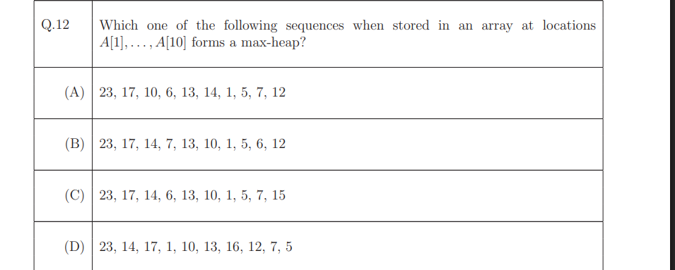

**What is a Max-Heap?**

A **max-heap** is a special type of **complete binary tree** where:

1. **The value at each node is greater than or equal to the values of its children.**
2. **The tree is complete**, meaning all levels are fully filled except possibly the last level, which is filled from left to right.

If the max-heap is stored as an array starting from index **1**, then:

* For any node at index i:
  + Left child is at index 2*i
  + Right child is at index 2*i + 1
  + Parent is at index i//2

Lets Check Option A : 23, 17, 10, 6, 13, 14, 1, 5, 7, 12

23 (A[1])

/ \

17 (A[2]) 10 (A[3])

/ \ / \

6 (A[4]) 13 (A[5]) 14 (A[6]) 1 (A[7])

/ \

5 (A[8]) 7 (A[9])

/

12 (A[10])

Heap **property violated here** because **14 > 10**, and 14 is a child of 10 . So **Option (A) is NOT a max-heap**.

Option (B): 23, 17, 14, 7, 13, 10, 1, 5, 6, 12

A[1] = 23 → Root node

/ \

A[2]=17 A[3]=14 → children of 23

/ \ / \

A[4]=7 A[5]=13 A[6]=10 A[7]=1

/ \ /

A[8]=5 A[9]=6 A[10]=12

Example of parent and child nodes relationship :

* Each **index** represents a **node**
* The **value at that index** is the **value of the node**
* Parent-child relationship is based on array indices:
* For **node at index i**:
  + - **Left child** = node at index 2*i
    - **Right child** = node at index 2*i + 1

**For instance :**

* Node at index 2 → value = 17
* Left child: index 4 → value = 7
* Right child: index 5 → value = 13

All parent nodes are ≥ their children . This is a **valid max-heap**!

Option (C) : 23, 17, 14, 6, 13, 10, 1, 5, 7, 15

23 (A[1])

/ \

17 (A[2]) 14 (A[3])

/ \ / \

6 (A[4]) 13 (A[5]) 10 (A[6]) 1 (A[7])

/ \ /

5 (A[8]) 7 (A [9]) 15 (A[10])

1. **Node A[4] = 6 has child A[9] = 7 → violation of max heap**
2. **Node A[5] = 13 has child A[10] = 15 → violation of max heap**

**multiple violations** exist in Option (C), making it **clearly not a max-heap**.

Option (D): 23, 14, 17, 1, 10, 13, 16, 12, 7, 5

23 (A[1])

/ \

14 (A[2]) 17 (A[3])

/ \ / \

1 (A[4]) 10(A[5]) 13(A[6]) 16(A[7])

/ \

12 (A[8]) 7(A[9])

\

5(A[10])

1 ≥ 12, 7 FALSE . **Violation here**: **1 < 12** and **1 < 7**

So again: **Option (D) is NOT a max-heap** .

The question is about analysing the **worst-case time complexity** of deleting a node from:

* A **singly linked list (SLL)** – SLLdel
* A **doubly linked list (DLL)** – DLLdel

A **singly linked list** is a linear data structure where each element (called a **node**) points to the **next node** in the sequence.

**Structure of a Node:** [ Data | Next ]

* **Data**: stores the value
* **Next**: stores a pointer/reference to the **next node**

**For Example:** [10| ] → [20| ] → [30| ] → null

Each node links to the next one, but **not backwards**.  
To reach a node, you must start from the **head** and follow the next pointers.

**Limitations:**

* No direct way to go backward
* To delete a node, you **need access to the previous node**

Lets say for example : [10] → [20] → [30] → [40] → null

You want to delete [30], and you're **only given**:

* A pointer to the **head** of the list
* A pointer to the **node to delete**: [30]

**Why can’t you just delete [30]?**

To delete a node in a singly linked list, you need to **update the .next of the previous node**.

In this case, you need to set:

20.next = 40

But you don’t have a direct way to access the previous node ([20]) from [30], because SLL only has .next.

**So What Do You Have to Do?**

You must:

1. Start from the **head** node
2. Traverse the list
3. Keep checking each node's .next
4. Stop when you find a node where: current.next == nodeToDelete

Once you find that node (current = 20), then you can do:

current.next = current.next.next;

**What makes it O(n)?**

Let’s say you want to delete the node with value x, and the list has n elements:

[1] → [2] → [3] → ... → [x] → ...

* Worst case: x is at the **end**
* You must check each node’s .next to find the one before x
* You might have to scan **all n nodes**

So it's a **linear scan**, and that makes it **O(n)**

**Why Not O(1)?**

O(1) means **constant time** — the operation takes the same time no matter how many elements there are.

To get O(1) deletion, you'd need:

* Direct access to the **previous node**
* Or the ability to **jump straight to the node before the one to delete**

In SLL, you **can’t go backward**, and there are **no shortcuts**, so you **can’t do it in O(1)** unless that previous node is already provided.

**Why Not O(log n)?**

O(log n) usually happens with **binary search** or **tree-based structures**, where you can eliminate half the data at each step — like:

* Binary Search Tree (BST)
* Balanced trees (e.g., AVL, Red-Black Trees)
* Binary search on arrays

But in an SLL:

* You **can’t jump** to the middle
* You **can’t divide the list**
* You must go **one node at a time**

So you can't get that logarithmic reduction — it's strictly linear traversal.

**Doubly Linked List (DLL)**

A **doubly linked list** is like a singly linked list, but each node has **two** pointers:

* One to the **next** node
* One to the **previous** node

**Structure of a Node:**

[ Prev | Data | Next ]

**For Example:** null ← [10] ↔ [20] ↔ [30] → null

Now you can traverse **both forward and backward** through the list.

**Advantages:**

* Can go backwards easily
* Can delete a node directly if you have a pointer to it (since you can access both neighbors)

Why is the time complexity of DLLdel (deleting a node from a Doubly Linked List) = O(1)?

Let’s break it down step by step

**Doubly Linked List (DLL) — Recap**

Each node has 3 parts: [ prev | data | next ]

So:

* You can go **forward** (node.next)
* And **backward** (node.prev)

**Goal: Delete a Node (say, B)**

Example DLL: null ←→ [A] ←→ [B] ←→ [C] ←→ null

Each connection:

* A.next = B, B.prev = A
* B.next = C, C.prev = B

**You Are Given a Pointer to Node B**

To delete B, you need to:

B.prev.next = B.next; // A.next = C

B.next.prev = B.prev; // C.prev = A

Now B is completely skipped.

**Why Is This O(1)?**

Because you already have **direct access** to B and its neighbors (B.prev and B.next) via pointers.

You don’t need to:

* Traverse from head
* Search for the node
* Count anything

All pointer updates are done in **constant time**, regardless of list size.

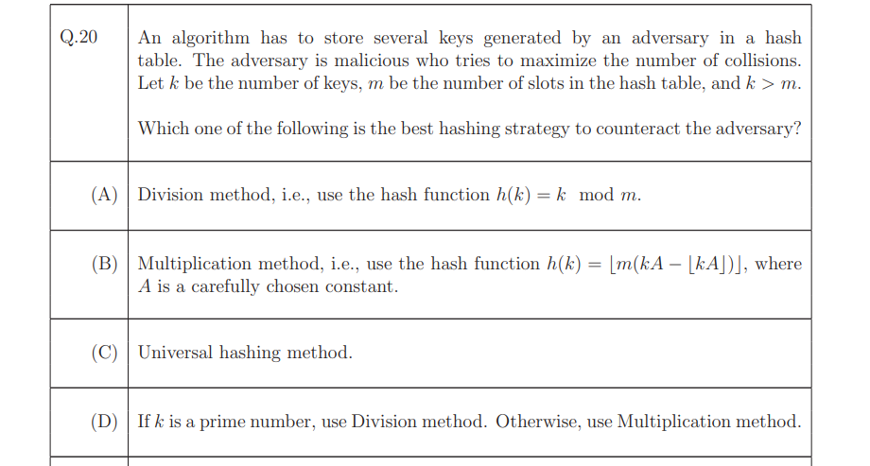

**Key Terms:**

* **Hash table**: A data structure that stores data using a key → hash function → index.
* **Collision**: When two keys end up at the same position in the hash table.
* **Adversary**: A malicious actor who tries to choose keys that cause many collisions.

**Problem Setup:**

* The attacker can **choose the keys**.
* k = number of keys (greater than number of slots m).
* We need a hashing method that makes it **hard for the attacker to force collisions**.

**What are the options?**

* **(A) Division method**: h(k) = k mod m
  + Simple and fast.
  + Easy for attacker to guess collisions if m is known.
* **(B) Multiplication method**: h(k) = floor(m * (kA mod 1))
  + More complex, less predictable.
  + Harder for attacker to predict collisions, if A is well-chosen.
* **(C) Universal Hashing**: Randomized hashing method.
  + **Best defense** against attackers.
  + Uses a randomly chosen function from a family of hash functions.
  + Since the attacker doesn’t know the function, it’s **very hard to create collisions**.
* **(D) Mix of division and multiplication depending on whether k is prime**.
  + Irrelevant to the security from attacker; not robust.

**Correct Answer: (C) Universal hashing method**

**Why?**

* Since the adversary **knows** the hash function (or can guess it), methods like division/multiplication are **predictable**.
* **Universal hashing** introduces **randomness** — the hash function is selected at random from a family of functions.
* Because the adversary doesn’t know **which** hash function will be used, they **cannot force collisions effectively**.

**In Simple Words:**

You want to store keys in a way that an attacker **can’t easily make them crash into each other** (collide).  
The best way is to pick your hash function **randomly from a secure pool** — so the attacker can’t predict how to cause damage.

That’s why **Universal Hashing** is the best answer here.

**Step-by-step Execution:**

1. **First Call: x = funcp();**
   * static int x = 1; → initializes x to 1 **only once**.
   * x++ → x becomes 2.
   * returns 2 → So, x = 2
2. **Second Call: y = funcp() + x;**
   * funcp() again:
     + x is already 2 (static retains its value)
     + x++ → becomes 3
     + returns 3
   * y = 3 + x → y = 3 + 2 = 5
3. **Final Output:**
   * x + y = 2 + 5 = 7

**Answer: 7**

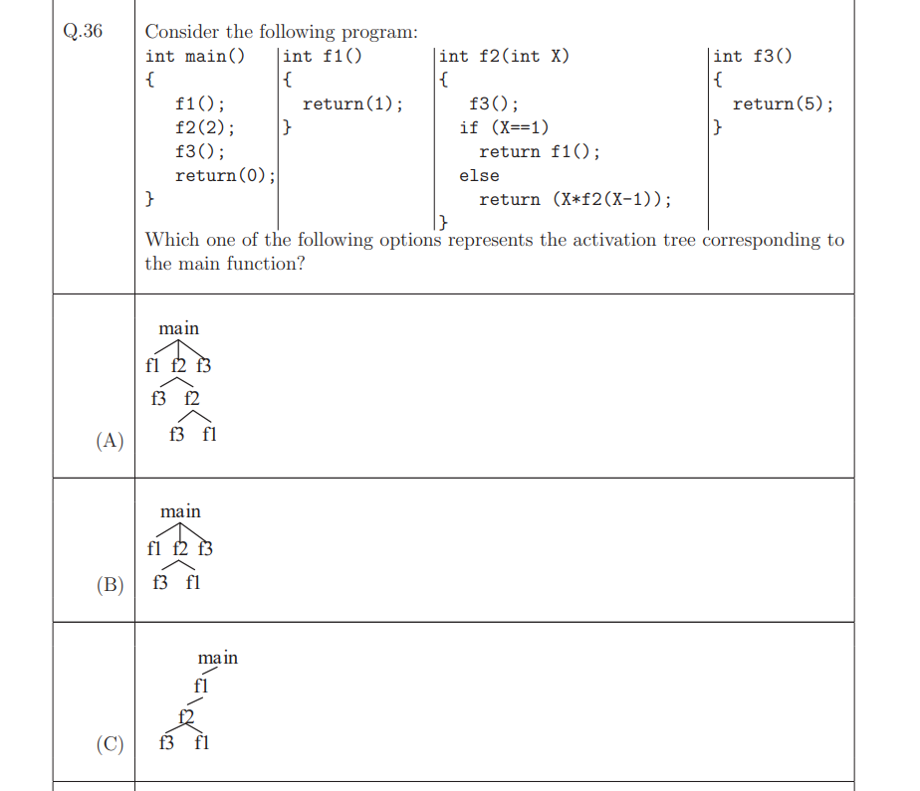

**What is an Activation Tree?**

An **activation tree** (also known as a **function call tree**) is a diagram that shows **how functions are called** during the execution of a program. Each node in the tree represents a function call. A function A that calls function B will have B as its child node in the tree.

It helps visualize **the order and nesting of function calls**, especially when functions call other functions recursively.

You are asked:

"Which option represents the **activation tree** of this program — i.e., which diagram shows how the function calls happen during execution?"

**Let's Simulate What Happens**

Here's what happens step-by-step in main():

1. f1() is called (simple, no further calls).
2. f2(2) is called:
   * It calls f3() first.
   * Then X != 1, so it calls f2(1):
     + f3() is called again.
     + X == 1, so it calls f1() again.
3. f3() is called again at the end.

If you look at option **(A)** :

It shows:

main

├── f1

├── f2

│ ├── f3

│ └── f2

│ ├── f3

│ └── f1

└── f3

This perfectly matches the flow we just described! Final Answer: **Option (A)**

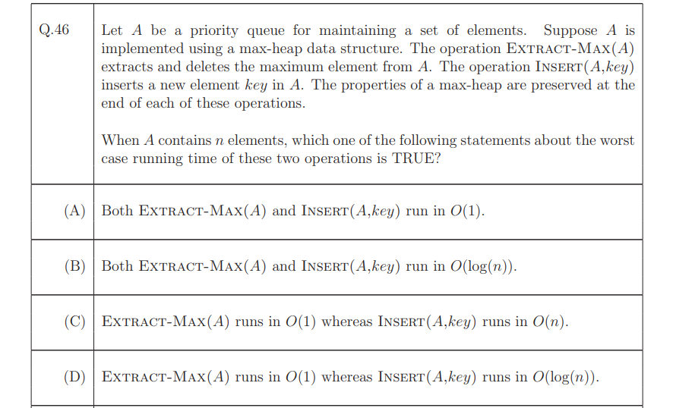

**Question Summary:**

You're given:

* A **priority queue A** implemented using a **max-heap**
* Two operations:
  + Extract-Max(A): removes and returns the **maximum element**
  + Insert(A, key): inserts a **new element**
* The question is asking about the **worst-case time complexity** of these two operations when A contains n elements.

**Key Concepts: Max-Heap Operations**

A **max-heap** is a binary tree where:

* Each parent is ≥ its children
* It's a **complete binary tree** stored as an array

**1. Extract-Max(A):**

* Removes the root (maximum element).
* To maintain the heap structure:
  + Replace root with last element
  + Then **"heapify down"** (i.e., swap down with the larger child)
* This may go all the way from root to leaf.

**Worst-case time**:  
O(log n) ← because height of a binary heap with n nodes is log n

**2. Insert(A, key):**

* Add new key at the end (maintains completeness)
* Then **"heapify up"** (bubble it up while parent < child)
* This may go from the bottom to the root.

**Worst-case time**:  
Also O(log n)

**Why Option (B) is correct:** (B) Both Extract-Max(A) and Insert(A, key) run in O(log n).

This exactly matches what we just discussed — both operations involve traversing the **height** of a binary heap, which is log n in a complete binary tree.

**Why Option (A) is incorrect:** (A) Both Extract-Max(A) and Insert(A, key) run in O(1).

* O(1) = constant time
* That would only be true if:
  + We removed the root without reheapifying (which would break the heap)
  + We inserted at the end without restoring heap order

**Heap structure would be violated** . **Not possible in a valid max-heap**

**Why Option (C) is incorrect:** (C) Extract-Max(A) runs in O(1) whereas Insert(A, key) runs in O(n).

* Extract-Max is **not O(1)** → we must heapify-down → takes **O(log n)**
* Insert is **not O(n)** → heapify-up only involves log n levels, not n

Incorrect on both counts

**Why Option (D) is incorrect:** (D) Extract-Max(A) runs in O(1) whereas Insert(A, key) runs in O(log n).

* Insert(A, key) **is correctly O(log n)**
* But **Extract-Max(A) is NOT O(1)** — it's O(log n) due to heapify-down

Half-correct ≠ correct answer

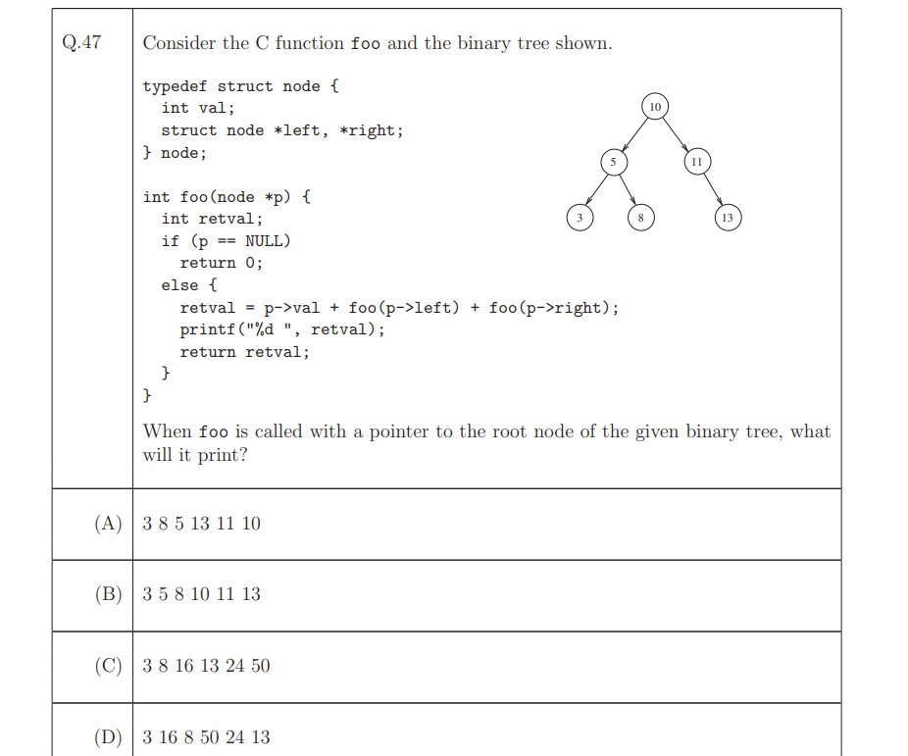

**What is the question asking?**

You are given:

1. A **binary tree** with integer values
2. A **C function named foo**
3. You are asked:

If foo() is called with a pointer to the **root node** of the binary tree (value = 10), **what will be printed?**

In other words:

* Understand the **order in which nodes are visited**
* Understand **what values get printed and when**

**Let’s Understand the C Code**

typedef struct node {

int val;

struct node *left, *right;

} node;

A basic structure for a binary tree node:

* val is the value stored in the node
* left and right are pointers to the left and right children

**Function: foo(node *p)**

int foo(node *p) {

int retval;

if (p == NULL)

return 0;

else {

retval = p->val + foo(p->left) + foo(p->right);

printf("%d ", retval);

return retval;

}

}

Let’s break this down:

1. **Base Case**: if (p == NULL) return 0;

If the current node is NULL (empty), return 0.

1. **Recursive Step**:

retval = p->val + foo(p->left) + foo(p->right);

This is the key line!

* It **recursively sums**:
  + the value of the **current node**
  + the result of **left subtree**
  + the result of **right subtree**

So it's doing a **post-order traversal** where:

* You process the **left subtree**
* Then the **right subtree**
* Then calculate and print the total for the **current node**

1. **Print and Return**:

printf("%d ", retval);

return retval;

* It prints the **sum of the subtree rooted at p**
* Then returns this sum to the parent call

**The Tree Structure**

10

/ \

5 11

/ \ \

3 8 13

Let’s label:

* Root: 10
* Left subtree: 5 → 3, 8
* Right subtree: 11 → 13

**How foo() Executes (Post-order traversal)**

Let’s simulate the recursion:

**Node 3:**

* Left & right are NULL → returns 3
* Prints: 3

**Node 8:**

* Left & right are NULL → returns 8
* Prints: 8

**Node 5:**

* Left = 3, Right = 8 → total = 5 + 3 + 8 = **16**
* Prints: 16

**Node 13:**

* Left & right NULL → returns 13
* Prints: 13

**Node 11:**

* Left = NULL, Right = 13 → total = 11 + 0 + 13 = **24**
* Prints: 24

**Node 10 (root):**

* Left = 16, Right = 24 → total = 10 + 16 + 24 = **50**
* Prints: 50

**Final Output Order:** 3 8 16 13 24 50

This matches **Option (C)**.

**Summary**

**What they’re asking:**

“What gets printed when the function foo() is called on the root node?”

**What the code does:**

* **Post-order traversal**
* Calculates the **sum of subtree values**
* **Prints the subtree sum at each node**, bottom-up

**Correct Answer: (C) 3 8 16 13 24 50**

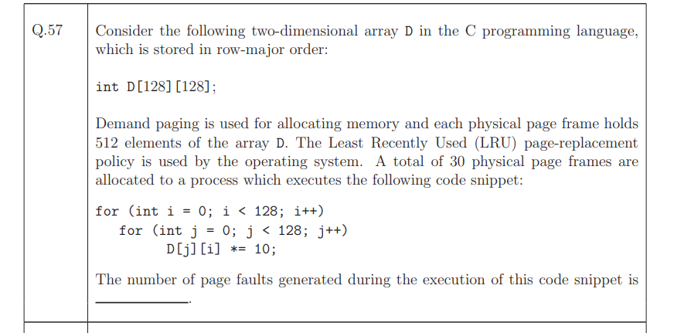

**What is demand paging?**

* It's a **virtual memory** concept.
* **Pages of a program are not loaded into memory until they're actually used.**
* If the program tries to access something **not currently in memory**, the **operating system raises a "page fault"**.
* Then the OS **loads the required page from disk into RAM**.

**Analogy:**

Imagine a huge book. Instead of carrying the entire book, you only carry the chapters you’re currently reading. If you need another chapter, you go fetch it.

So, in your program — **only the parts of the array that are actively being used get loaded into RAM**.

**"Each physical page frame holds 512 elements of the array"**

**What is a physical page frame?**

* It's a **fixed-size block** of physical memory (RAM).
* Think of RAM being divided into equally-sized **slots**.
* Each of these slots is called a **page frame**.

**What does "holds 512 elements" mean?**

* The array is made of ints (integers).
* Each frame (slot in memory) can store **512 integer values** from the array.
* So, if you load part of the array into memory, **512 integers (elements) come in at once.**

**For Example:**

If your array is D[128][128], that’s 16,384 integers total.  
Each page frame holds 512 integers.  
So, to store the entire array, you'd need:  
16,384 / 512 = 32 page frames.

But your OS only gives you **30 page frames** to work with. So at any time, **2 pages won’t fit**, and **LRU (Least Recently Used) policy** is used to evict old ones.

**Putting it all together:**

* The array D[128][128] is **too big to fit entirely in RAM**.
* The OS uses **demand paging** to load only parts of the array **when needed**.
* Each **page fault** happens when a part of the array is accessed but **not currently in memory**.
* And each time, **a block of 512 integers is loaded** into a **page frame**.

**How does RAM work here?**

**RAM = Main Memory**

* RAM is **fast memory** where your program runs.
* But it is **limited** in size (e.g., 8 GB, 16 GB).
* So it can’t store **everything** at once.

**What Happens:**

1. The program starts. The OS puts some **initial pages** into RAM.
2. The program accesses **new data or code**.
3. If it’s not already in RAM → **Page fault** occurs.
4. OS takes that missing page from **disk** (virtual memory) → loads it into **RAM**.
5. If RAM is full, the OS may **remove (evict)** an old page from RAM using a policy like LRU (Least Recently Used).

**What is a Page Fault?**

A **page fault** occurs when:

The program **tries to access a page** that is **not in RAM**.

**Here's what happens in a page fault:**

1. The CPU tries to access memory (e.g., a variable).
2. The **Memory Management Unit (MMU)** checks the page table.
3. It finds that the required page is **not in RAM**.
4. ❗ **Page Fault triggered** — like a red flag!
5. OS **pauses the program**, goes to the **disk**, and **loads that page** into RAM.
6. If RAM is full → OS may **remove an old page** (like closing a tab in a browser).
7. The page is loaded, and the program **resumes exactly where it left off**.

**Analogy:**

Imagine you’re reading a book on a tablet with limited memory.

* You start reading Chapter 1 — it's loaded in memory.
* You scroll to Chapter 3 — the tablet goes: “Oh! That’s not loaded yet.”
* It downloads Chapter 3 from the internet (like fetching a page from disk).
* It might remove Chapter 1 if memory is full.

That "download" = **page fault**.

**Now the actual answer is 4096.**

**What the Official Answer is Assuming:**

They’re assuming:

Each page holds 512 elements

Each row has 128 elements

So: 4 rows fit per page (since 512/128 = 4)

Total rows = 128 → so:

128 / 4 = 32 pages are needed to store all rows

Now look at the access:

D[j][i] → access 1 element from each row

So in 1 column, we access 128 rows = 32 pages (again)

So: in each of the 128 outer loop iterations, 32 page accesses are made.

Because only 30 pages fit in memory:

In every column, 2 pages must be evicted (as only 30 can stay in RAM)

So every column iteration causes 2 new page faults

But this is not how the answer key got 4096.

**Here’s how they did it:**

Each page holds **512 elements**.

Each **access** is to a single element, and there are **16,384 accesses** (128 × 128).

So:

* Each **access** may trigger a page fault, but once a page is loaded, other accesses to it may not.

Because the access pattern jumps across rows (D[j][i]), and each page stores **4 rows**, every **i iteration** accesses 128 rows → thus **32 pages**.

So:

* Each i (128 total) → accesses **32 pages**
* So: **total page accesses = 128 × 32 = 4096**
* All are **page faults**, because LRU can’t retain them all (only 30 pages)

**Answer = 4096 page faults**

**Final Summary:**

* Each column access = 128 elements → 32 different pages
* 128 such columns → **128 × 32 = 4096**
* That's the total number of page faults when every access triggers a page fault (due to poor locality)
* **Answer = 4096**

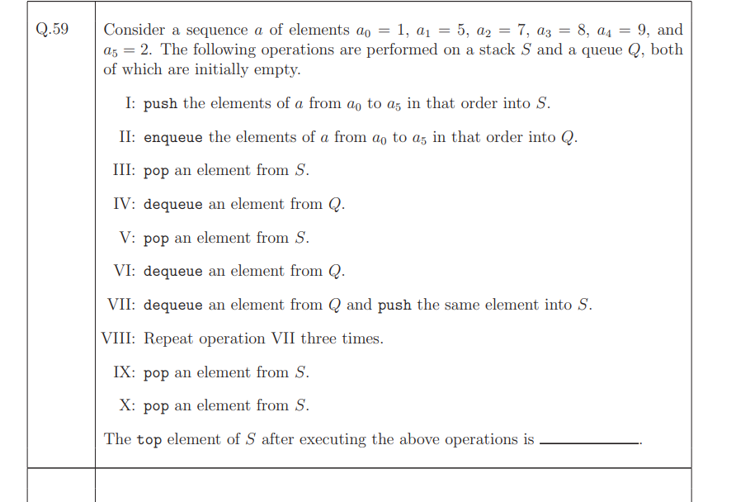

You are given:

* A sequence of elements:  
  a = [1, 5, 7, 8, 9, 2]  
  (These are a₀ to a₅)
* Two data structures:
  + **Stack** S (Last-In-First-Out)
  + **Queue** Q (First-In-First-Out)
* Initially both S and Q are empty.

You are told to:

* Perform a sequence of operations (I through X)
* After all operations, tell **what is the top element of the stack S**

**Step-by-step execution**

**Step I: Push a₀ to a₅ into S**

Sequence: 1, 5, 7, 8, 9, 2 → push into **Stack S**

Since stack is **LIFO**, top is the last pushed.

After step I:  
S = [1, 5, 7, 8, 9, 2] ← 2 is on top

**Step II: Enqueue a₀ to a₅ into Q**

Sequence: 1, 5, 7, 8, 9, 2 → enqueue into **Queue Q**

Since queue is **FIFO**, front is the first enqueued.

After step II:  
Q = [1, 5, 7, 8, 9, 2] ← 1 is at front

**Step III: Pop from S**

S.pop() → removes 2  
Now: S = [1, 5, 7, 8, 9]

**Step IV: Dequeue from Q**

Q.dequeue() → removes 1  
Now: Q = [5, 7, 8, 9, 2]

**Step V: Pop from S**

S.pop() → removes 9  
Now: S = [1, 5, 7, 8]

**Step VI: Dequeue from Q**

Q.dequeue() → removes 5  
Now: Q = [7, 8, 9, 2]

**Step VII: Dequeue from Q and Push to S**

Dequeue → 7, Push to S  
Now:

* Q = [8, 9, 2]
* S = [1, 5, 7, 8, 7]

**Step VIII: Repeat VII three times**

1. Dequeue 8, Push to S → S = [1, 5, 7, 8, 7, 8], Q = [9, 2]
2. Dequeue 9, Push to S → S = [1, 5, 7, 8, 7, 8, 9], Q = [2]
3. Dequeue 2, Push to S → S = [1, 5, 7, 8, 7, 8, 9, 2], Q = []

**Step IX: Pop from S**

S.pop() → removes 2  
Now: S = [1, 5, 7, 8, 7, 8, 9]

**Step X: Pop from S**

S.pop() → removes 9  
Now: S = [1, 5, 7, 8, 7, 8]

**Final Answer:**

**Top element of S = 8**

**Answer: 8**